|  |  |  |  |  |  |
| --- | --- | --- | --- | --- | --- |
| Date | 1-Dec-22 | | | Tester Name | Janette Paus |
| Environment | Penfax - Test 2 | | | Login used |  |
| Operating System | Windows | Version: 21H2 | Update Number: | | |
| Software Used | Select Software | Version: 107.0.1418.56 | Update Number: | | |
| Select Software | Version: | Update Number: | | |
| Application Release version | R22.4.1 | | | | |
| Test Case Title | E20.04 | | | | |
| Test Type | Regression | | | | |
| Test Scenario | Reverse a Contribution Posting after Valuation | | | | |
| Expected Results | The contribution will b manually reversed, record by record & the funds will not appear in the member’s accounts. The breakage entries will be reasonable. | | | | |
| Pass/Fail | Pass | | | JIRA# |  |

Go to data posting batches, find a closed contribution file (ensure it wasn’t processed by a tester).

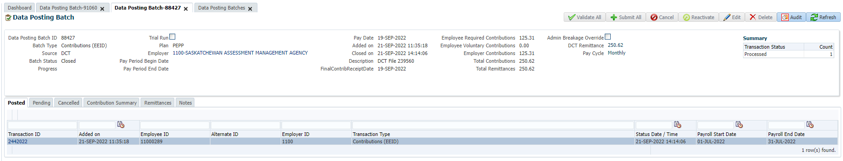

Search the member in Penfax and pull up their person profile, payroll history:

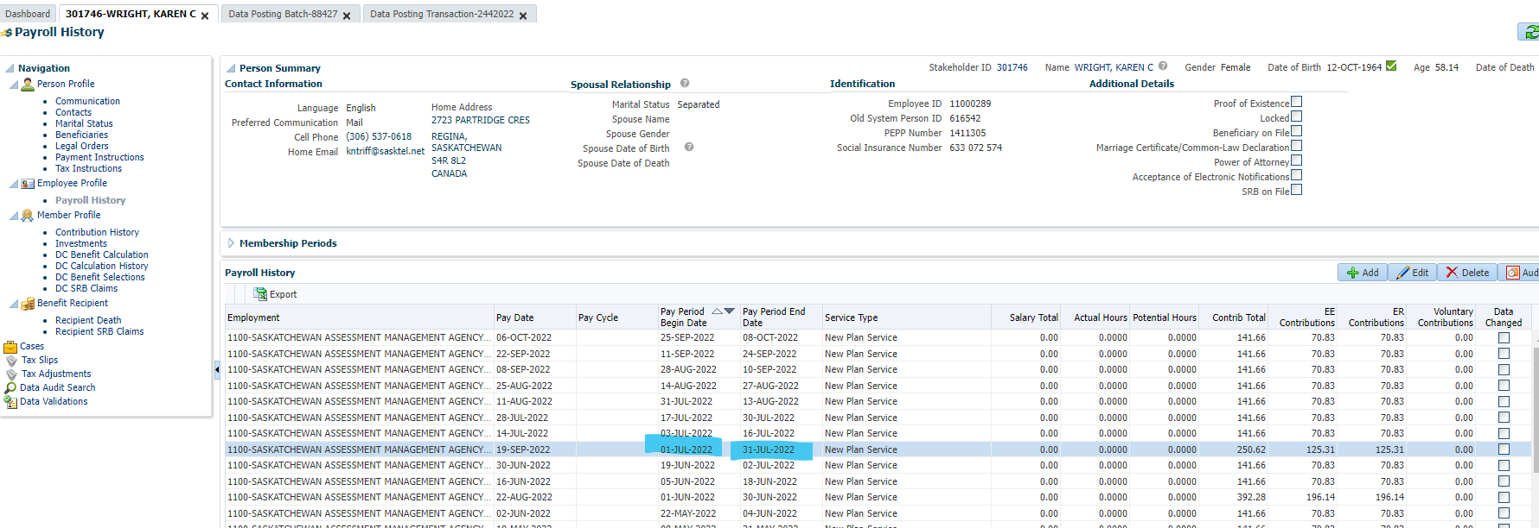

Go to contribution history and validate that the effective date matches in the investments screen:

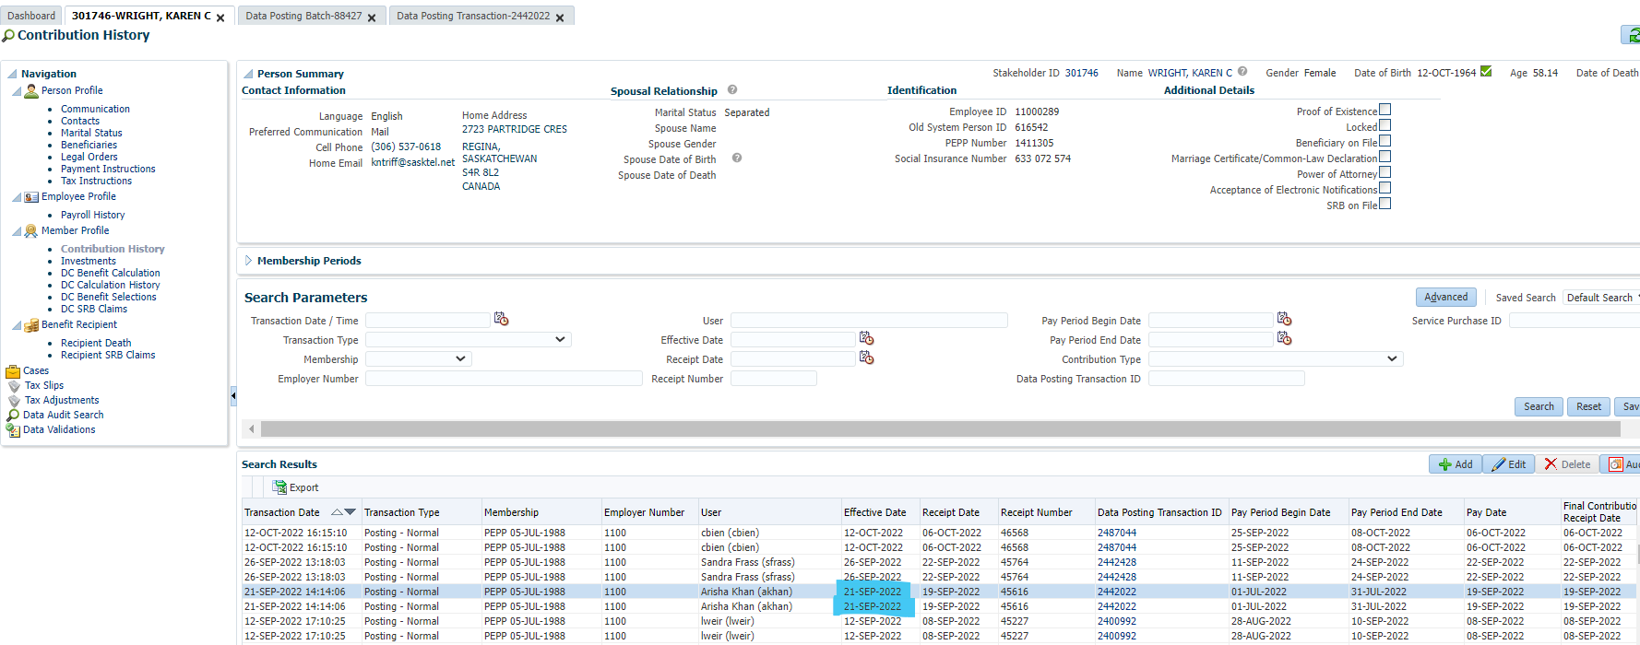

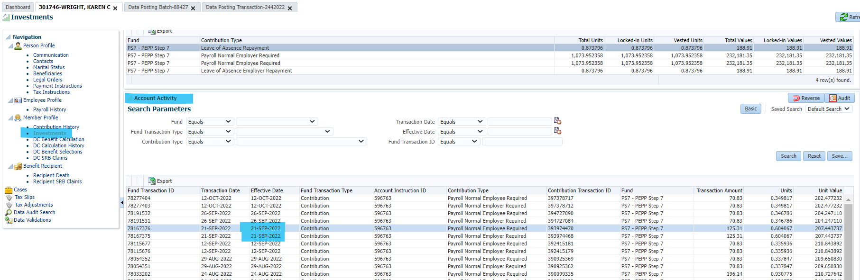

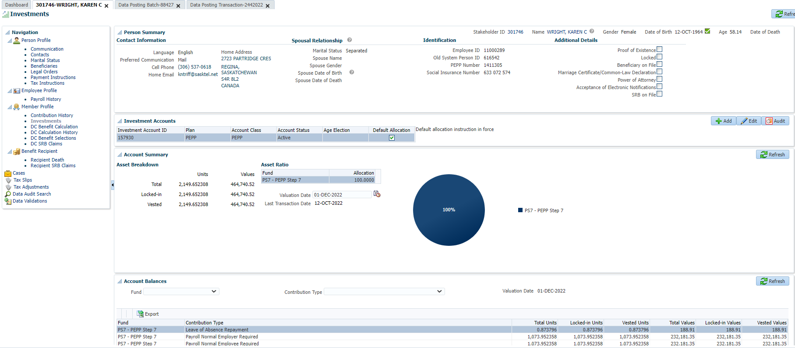

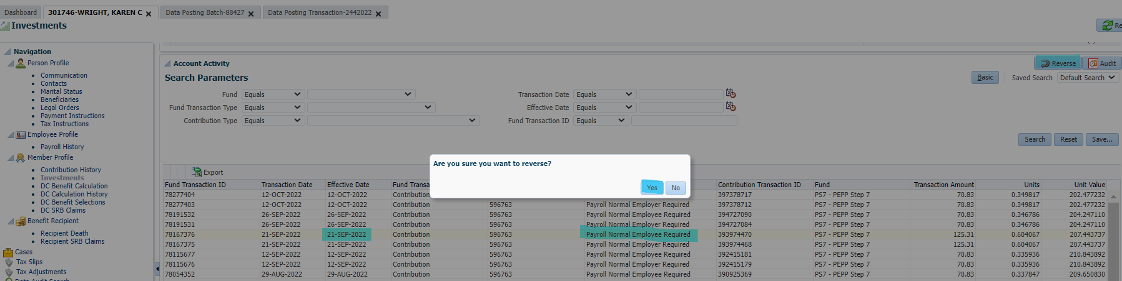

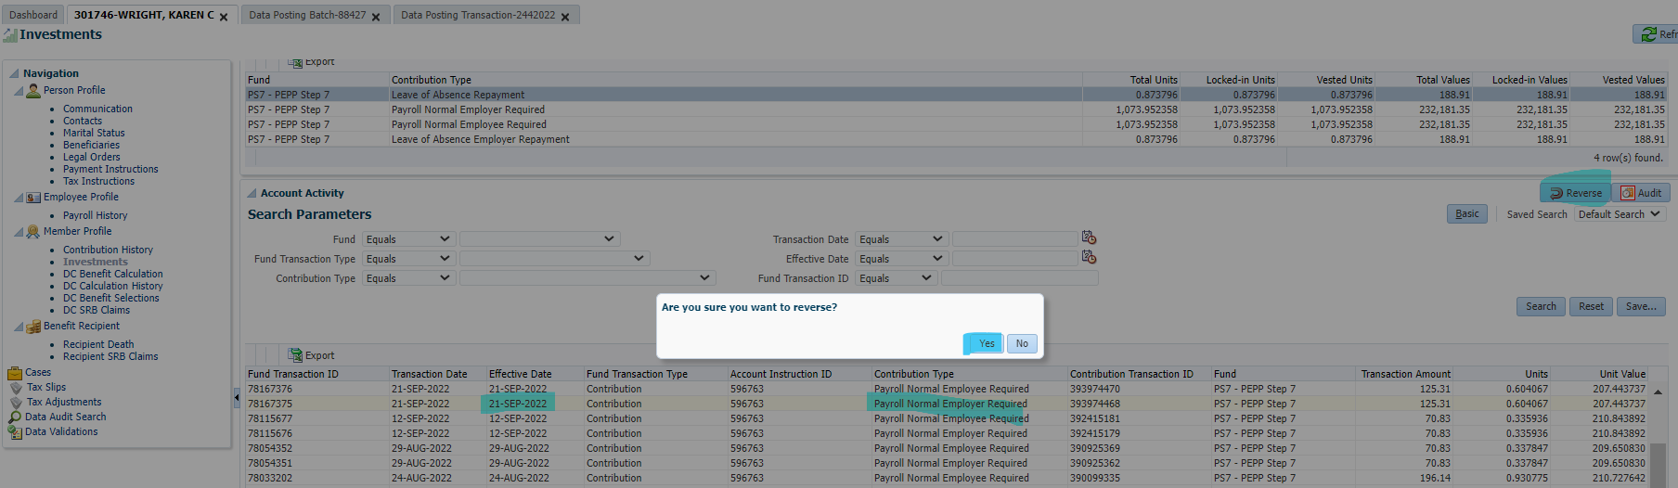

Next Day:

Double check funds were removed from member’s account & Reverse breakage occurrence, if any.

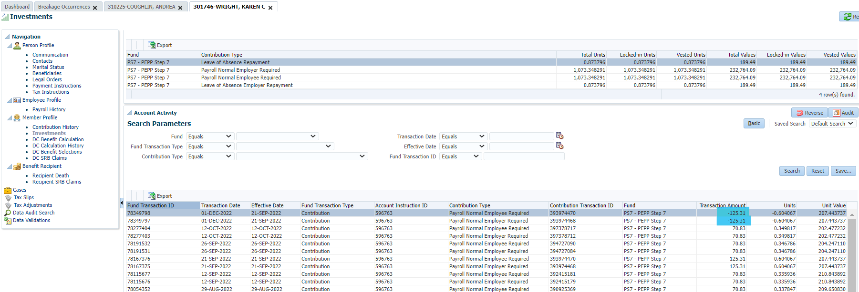

Breakage occurrence is correct:

